**Exercise 1.2 Solution**

* Like before, we begin with the entities and relationships.
* “…artists, their names (which are unique), birthplaces, age, and style of art.”
* “For each piece of artwork, the artist, the year it was made, its unique title, its type of art … and its price must be stored.”
* Like before, we begin with the entities and relationships.
* “…artists, their names (which are unique), birthplaces, age, and style of art.”
* “For each piece of artwork, the artist, the year it was made, its unique title, its type of art … and its price must be stored.”

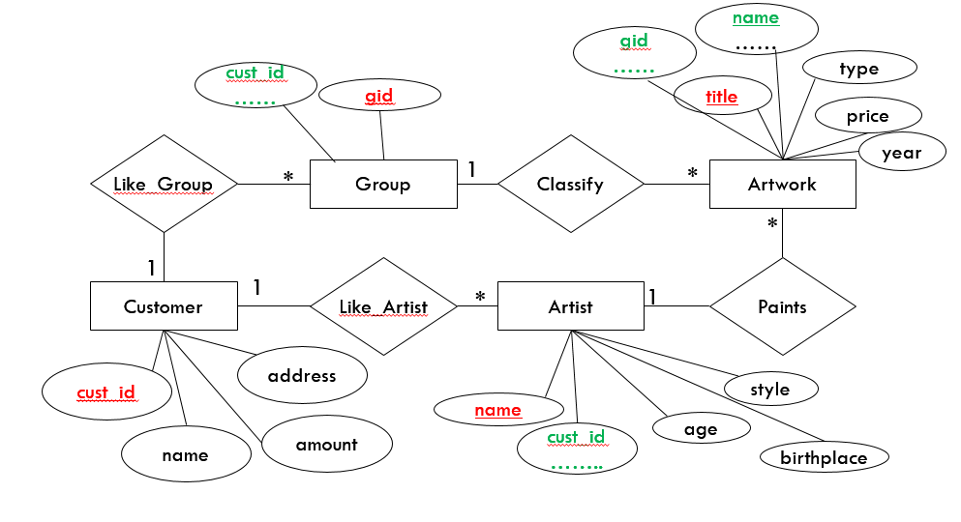

Attributes written with red: Primary Keys

Attributes writtern with green are foreign keys